From Soil to Server:
Enhancing Plant Care Through Real-Time Monitoring



School of Computer Applications
Lovely Professional University
Punjab

Submitted by-
Akash Verma

CONTENTS

S. No. | Content | Pg no.
1. | Abstract | 3
2. | Introduction | 4
2. | Related Work | 6
3. | Project Implementation | 8
4. | Conclusion | 12
5. | Future Scope | 13

ABSTRACT

This project explores real-time plant care automation using a Raspberry Pi-based monitoring system. It integrates sensors and an online server to track and control soil and water levels.
This project, titled "From Soil to Server: Enhancing Plant Care Through Real-Time Monitoring," focuses on improving plant care using technology to monitor essential environmental factors. The system integrates a Raspberry Pi, soil moisture and water level sensors, a water motor, and a relay to create an automated plant care solution. The Raspberry Pi processes data from sensors and sends updates to the Blynk cloud server, allowing real-time monitoring and control via a user-friendly interface. An I2C display provides on-site information, while a battery ensures uninterrupted operation. This project offers a sustainable solution for plant care, especially for individuals with limited time or remote access, by enabling efficient water management and reducing resource wastage. Through this setup, the project explores how IoT technologies can simplify and enhance agricultural practices.
Successfully developed a real-time monitoring system that automates plant watering based on soil moisture and water levels, reducing manual effort and conserving water. Integrated with Blynk cloud, the system provides remote access and real-time updates for improved plant care management.

INTRODUCTION

Our project, From Soil to Server: Enhancing Plant Care Through Real-Time Monitoring, establishes a unique IoT-based system for automated plant care. Unlike previous works that often focused on either security or limited small-scale irrigation, this project combines soil moisture, water level sensors, and a Raspberry Pi for real-time monitoring, adaptive irrigation control, and continuous data updates. Using a relay and water motor for irrigation, it integrates with the Blynk cloud for remote monitoring, enabling easy access and adjustments. An on-site I2C display provides immediate feedback, making the system efficient, comprehensive, and user-friendly, enhancing plant care sustainably and at scale.
Personalized Plant Care with Blynk: Pappula et al. (2024) [1] developed an IoT system with Blynk and machine learning for personalized plant care. This supports our project’s use of Blynk for remote monitoring and real-time updates, enabling effective plant health management.
Early Detection and Monitoring: R et al. (2024) [2] created GreenSense, an IoT-enabled system for early plant health detection in greenhouses. Similarly, our project aims to detect soil moisture levels early to prevent under-watering and maintain plant health.
Precision Irrigation: Daniel et al. (2024) [3] implemented IoT for precise bonsai irrigation. This relates to our use of soil moisture sensors and automated watering, allowing tailored water supply for different plants’ needs.
Water Efficiency through Automation: Kumar et al. (2024) [4] focused on enhancing water efficiency using IoT and automation in smart farming. In our project, automated control of the water motor based on soil moisture readings supports water conservation.
Sustainable Precision Agriculture: Chavakula et al. (2024) [5] emphasized IoT-based sustainable agriculture. Our project’s remote monitoring and controlled irrigation contribute to sustainability by reducing manual intervention and optimizing water use.

RELATED WORK
Prior work in Enhancing smart Plant care system has proposed architectures that focus on the use of low-cost open-source hardware components like Arduino, RPI, MCU boards and a combination of sensors.
R et al. [2] introduced GreenSense, an IoT-enabled smart monitoring system designed for optimal plant health in greenhouses. Their architecture enables early detection of plant health issues through a variety of sensors. However, the system’s effectiveness is constrained by limited connectivity in remote areas, impacting real-time data transmission and decision-making accuracy.
Kumar et al. [4] proposed an IoT and CNN-based smart farming system focused on water efficiency, automation, and disease detection. The system provides robust plant health monitoring with real-time imaging for disease diagnosis. However, its high computational demands make it less suitable for low-power, battery-operated devices in remote or off-grid settings.
Kumar et al. [6] proposed an IoT-based smart irrigation system using a soil moisture sensor and automatic water pump control. This study highlighted efficient water usage by automating pump operations based on real-time soil conditions. However, the system lacks advanced data analytics for predictive irrigation, which could optimize water conservation further.
Tia et al. [7] developed an IoT-based soil monitoring and irrigation system to improve crop growth. The system continuously monitors soil moisture to regulate water supply, although the system’s basic design does not incorporate machine learning, limiting adaptability to diverse crop requirements.
Mukherjee and Debnath [8] conducted a survey on IoT-based smart agriculture monitoring systems, outlining the benefits of IoT for real-time crop and soil management. While comprehensive, this study highlights the need for more robust data security measures to protect sensitive agricultural information.
Yadav et al. [9] created an automatic irrigation and soil moisture monitoring system using IoT, which automates irrigation based on moisture levels. The system’s drawback is the lack of integration with weather data, which could improve water management in changing environmental conditions.
Haq et al. [10] proposed a smart agriculture monitoring system for real-time farm data analysis. Their system provides continuous feedback for crop management, but limited connectivity in rural areas poses challenges for real-time monitoring.
COMPARITIVE ANALYSIS OF EXISTING METHODS

Table 1: Comparative Analysis

Autor (Year) | Techniques Used | Pros | Cons
R et al. [2] (2024) | IoT-enabled smart monitoring for greenhouse plants | - Early plant health detection | - Limited connectivity in remote areas
Kumar et al. [4] (2024) | IoT with CNN for water efficiency and disease detection | - Automated disease detection | - High power requirements for remote operation
Kumar et al. [6] (2019) | IoT-based smart irrigation with soil moisture sensor | - Automated water management | - Lacks predictive analytics for optimal water usage
Tia et al. [7] (2020) | IoT-based soil monitoring and irrigation | - Improved crop growth through continuous monitoring | - No machine learning for diverse crop needs
Mukherjee & Debnath [8] (2021) | Survey on IoT in agriculture | - Real-time crop and soil insights | - Limited data security measures
Yadav et al. [9] (2019) | Automatic irrigation with soil moisture monitoring | - Effective moisture-based irrigation control | - Does not use weather data
Haq et al. [10] (2018) | IoT system for smart agriculture | - Real-time data for crop management | - Connectivity issues in rural areas

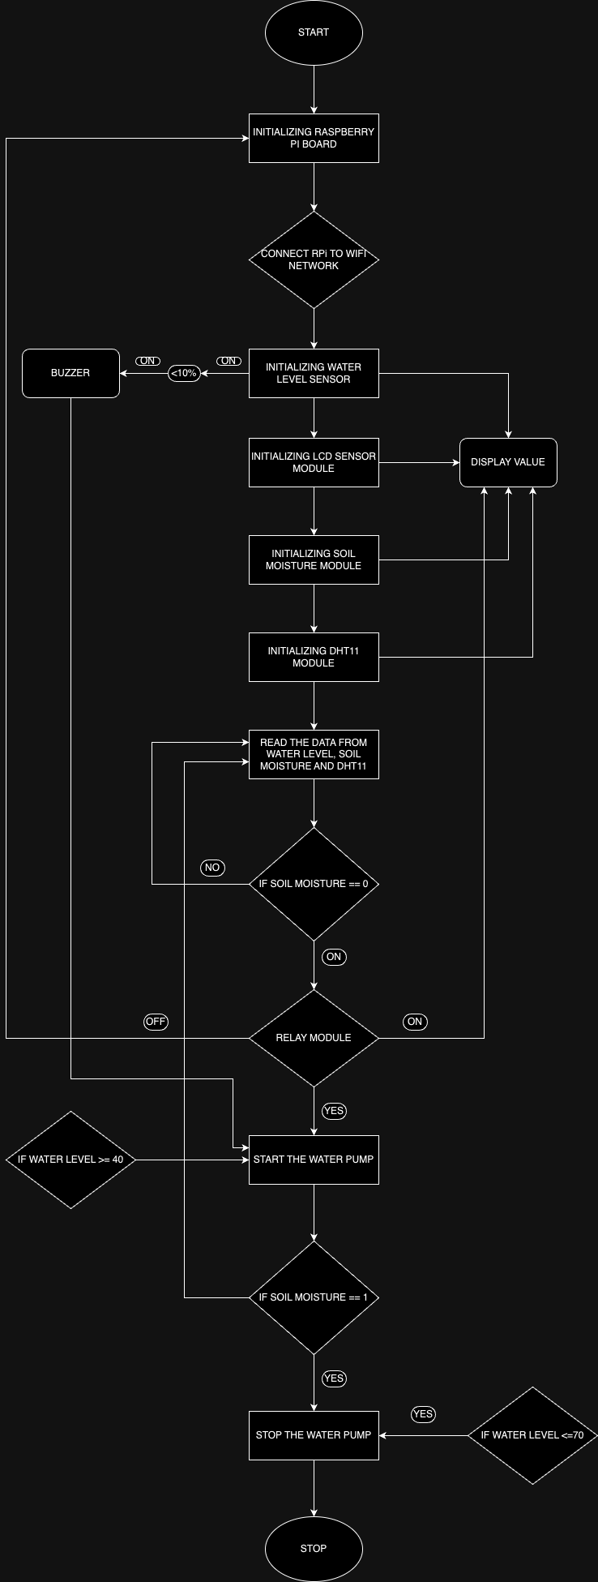
PROJECT DESCRIPTION FLOWCHART

Figure 1.1 Flow Diagram
PROJECT IMPLEMENTATION


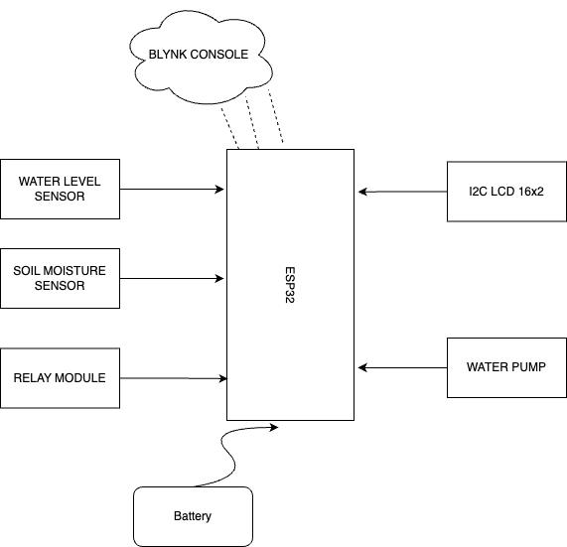
- Block Diagram
raspberry pi
Raspberry Pi
Figure 1.2 Block Diagram

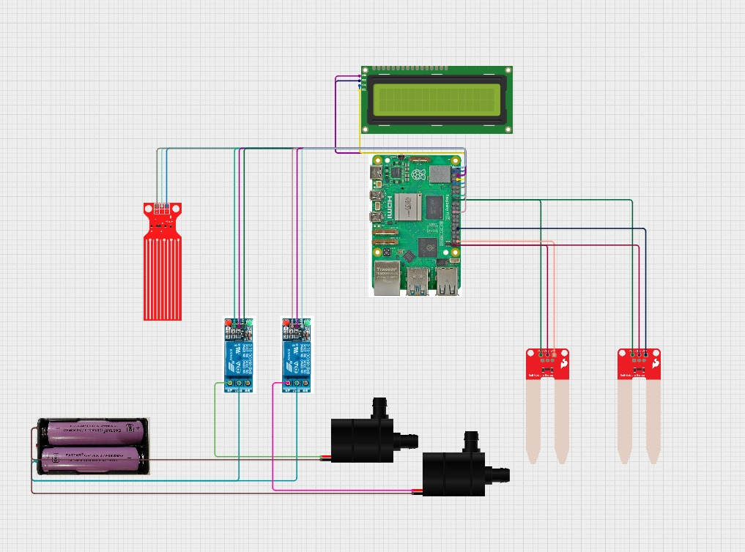
- Circuit Diagram

Figure 1.3 Circuit Diagram
- Working
The "Smart Irrigation System" leverages a Raspberry Pi microcontroller, soil moisture sensor, water level sensor, and the Blynk app to create an automated, remotely accessible irrigation system. Here’s a detailed overview of the project’s operation:
  - Water Level Monitoring
- A water level sensor is placed inside the reservoir or water tank to measure the water level consistently.
- This sensor monitors the water level in real-time, sending data to the Raspberry Pi via digital or analog signals
- The Raspberry Pi processes the incoming data and determines the current water level, using it to decide whether refilling or irrigation adjustments are necessary.

  - Soil Moisture Monitoring
- A soil moisture sensor is embedded within the irrigation area to detect moisture levels directly in the soil.
- The sensor periodically measures soil moisture content and sends the data to the Raspberry Pi for analysis.
- The Raspberry Pi evaluates these readings and determines the soil’s need for water based on predefined thresholds.

  - Remote Control via Blynk
- The Blynk mobile application serves as a user-friendly interface for monitoring and controlling the system remotely.
- Users install the Blynk app on their smartphones, configuring it with an authentication token to connect directly to the system.
- The app displays real-time data on water levels and soil moisture, enabling users to monitor the system remotely and make on-the-fly adjustments as necessary.

  - Automated Operation
- The Raspberry Pi continually monitors data from both the water level and soil moisture sensors.
- Based on user-defined thresholds or default settings, the Raspberry Pi determines when irrigation should be triggered.
- If the soil moisture falls below the specified threshold or if the water level in the reservoir is low, the Raspberry Pi activates the irrigation process.

  - Irrigation Control
- The Raspberry Pi controls the irrigation mechanism by activating a water pump via a relay module connected to the motor.
- When irrigation begins, the Raspberry Pi turns on the water pump, distributing water through irrigation lines or drip emitters to effectively water the plants.
- Users can set irrigation duration and frequency based on plant needs, environmental factors, or their own preferences.

  - Feedback and Optimization
- During the irrigation process, the system provides feedback to the user through the Blynk app, displaying real-time updates on water levels, soil moisture, and irrigation activity.
- Users can monitor these parameters remotely, adjusting the irrigation schedule or settings as needed to optimize water usage and maintain plant health effectively.
- This setup allows for a flexible, user-centric approach to plant care, ensuring efficient water use and minimizing manual intervention.

CONCLUSION

The “From Soil to Server: Enhancing Plant Care Through Real-Time Monitoring” project has successfully demonstrated how IoT technology can streamline plant care through automation. By integrating sensors for soil moisture and water levels, the system intelligently determines optimal watering schedules, minimizing the need for manual intervention. The use of a relay and water motor enables precise control over irrigation, contributing to efficient water use, which is critical in water-scarce environments.
With the Raspberry Pi serving as the control hub, data from the sensors is processed and displayed on an I2C display for easy, local monitoring. The Blynk cloud platform further enhances this by providing remote access to real-time updates, ensuring users can monitor their plants from anywhere. This dual local and cloud-based setup adds robustness to the system, offering both reliability and convenience.
In summary, this project provides a scalable solution for automated plant care, balancing technology with environmental consciousness. It demonstrates how simple yet effective IoT applications can contribute to sustainable gardening practices. The project has the potential to be expanded with additional sensors or features, paving the way for more sophisticated and adaptable plant care solutions in the future.

FUTURE SCOPE
1. Integration of Weather Data: Integrating real-time weather data can significantly enhance water efficiency by adjusting irrigation schedules based on rainfall, temperature, and humidity forecasts. This would optimize water usage, reducing unnecessary irrigation during rainy or high-humidity conditions.
2. Machine Learning for Adaptive Irrigation: Machine learning algorithms can enable the system to adapt to specific plant requirements, soil types, and seasonal changes. This would allow the system to "learn" and predict water needs for each plant, enhancing conservation and promoting plant health.
3. Distributed Sensor Networks: Expanding to a network of soil moisture sensors across different zones can provide more precise irrigation control. This approach allows for customized watering based on specific plant types or soil conditions, ensuring each area gets the water it needs.
4. Disease and Pest Detection: Adding disease and pest detection through image recognition or specialized sensors can make the system proactive in plant health management. Early detection helps prevent damage, maintaining a healthier growing environment.
5. Enhanced User Interface and Analytics: Developing a more advanced interface with visualized data on soil conditions, water usage, and trends would improve user experience and decision-making. Access to analytics makes the system more user-friendly and actionable.
6. Smart Home Integration: Integrating with smart home platforms like Google Home or Alexa would allow users to control irrigation via voice commands and include plant care within their broader home automation. This would add convenience and allow seamless operation in a smart home environment.

REFERENCES

[1] Pappula, M., Myneni, J. C., Gandra, M., Tadigadapa, R., & Akella, B. K. M. (2024). Blynk-Powered IoT system with machine learning for personalized plant care. 2024 8th International Conference on Inventive Systems and Control (ICISC)
[2] R, V., R, A. K., & M, K. (2024). GreenSense: IoT-Enabled smart monitoring and Early detection system for optimal plant health in Greenhouse. 2024 International Conference on Advances in Data Engineering and Intelligent Computing Systems (ADICS)
[3] Daniel, V., Ramalakshmi, K., Venkatesan, R., Sundar, G. N., Nancy, G., & Shirly, S. (2024). Precision cultivation for bonsai through IoT implemented smart irrigation. 2024 3rd International Conference on Applied Artificial Intelligence and Computing (ICAAIC)
[4] Kumar, A., Upadhay, H. K., & Iqubal, J. N. M. (2024). SMART FARMING SYSTEM: Enhancing water efficiency, automated care, and disease detection using IoT and CNN. 2024 Advances in Science and Engineering Technology International Conferences (ASET)
[5] Chavakula, S. J., Mahamuni, C. V., Agrawal, K. D., Alla, N. R., & Adhav, Y. S. (2024). Smart Plant Monitoring: an integrated IoT system for sustainable precision agriculture. 2024 MIT Art, Design and Technology School of Computing International Conference.
[6] A. Kumar et al., "IoT-Based Smart Irrigation System Using Soil Moisture Sensor and Automatic Water Pump Control," International Journal of Recent Technology and Engineering, 2019.
[7] M. H. Tia et al., "IoT-Based Smart Irrigation System and Soil Monitoring for Crop Improvement," International Journal of Engineering and Technology, 2020.
[8] S. Mukherjee and S. Debnath, "A Survey on IoT-Based Smart Agriculture Monitoring Systems," Journal of Agricultural Informatics, 2021.
[9] S. K. Yadav et al., "Automatic Irrigation and Soil Moisture Monitoring System Using IoT," Journal of Information Systems and Technology Management, 2019.
[10] A. U. Haq et al., "Smart Agriculture Monitoring System Based on IoT," International Journal of Advanced Computer Science and Applications, 2018.
[11] R. K. Gupta et al., "IoT-Based Soil Nutrient and Plant Health Monitoring System," International Journal of Computer Applications, 2021.
[12] V. K. Mittal et al., "IoT-Enabled Plant Watering System with Mobile App Interface," IEEE Internet of Things Journal, 2019.
[13] P. K. Singh et al., "An IoT-Based Framework for Efficient Plant Growth Monitoring and Automated Watering," Sensors, 2020.
[14] J. Lee et al., "Development of IoT-Based Precision Agriculture Platform for Smart Farming," Computers and Electronics in Agriculture, 2021.
[15] M. D. A. Khan et al., "Smart Plant Monitoring System Using IoT with Mobile App," International Journal of Electronics and Communication Engineering, 2019.
[16] S. R. Reddy and R. G. Prasad, "IoT-Based Water Level Monitoring for Agricultural Fields," International Journal of Scientific Research in Science and Technology, 2020.
[17] S. Sharma and P. Jain, "IoT and Cloud-Based Solution for Agricultural Field Monitoring," Procedia Computer Science, 2019.
[18] N. K. Subramanian et al., "An IoT and Cloud-Based Smart Agriculture System for Real-Time Plant Health Monitoring," Journal of Applied Sciences, 2018.
[19] F. Abbasi et al., "Real-Time Monitoring and Control of Agricultural Environment Using IoT and Cloud Technologies," Sustainable Computing: Informatics and Systems, 2020.
[20] A. Dey and S. Kumar, "IoT-Based Plant Monitoring System with Blynk Cloud for Remote Access," International Journal of Computer Applications, 2019.

